**Odb2vtk User Guide**

(Release 1.0)

By: LIU, Qingbin & LIU, Jie

December 4, 2016

Odb2vtk is a Python script that converts Abaqus output ODB files to VTK format. To use odb2vtk is quite easy -- only 3 simple steps.

# 1 Preparation

Please ensure that Abaqus Python is already on your computer.

Copy “odb2vtk.py” to the directory of python lib of Abaqus Python, such as:

C:\SIMULIA\Abaqus\6.14-1\code\python2.7\lib

Type command “Abaqus Python” and return, and then type “from odb2vtk import *” (see Fig. 1).

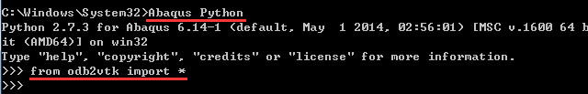

Fig. 1. Preparation of using odb2vtk.

# 2 Configuration

Here we mean the configuration of task. The following information should be specified:

* ODB file: the filename and path of Abaqus output.
* VTK files path: the fold to save the converted vtk files.
* Mesh type: element type represented by a number, e.g., 10 is tetrahedron elements, 12 is hexahedron elements. For other mesh types, please refer to “vtk file formats” in http://www.vtk.org/wp-content/uploads/2015/04/file-formats.pdf
* Piece number: the number of pieces that the model will be partitioned into.
* Frames: the number of frames to be processed
* Steps: the number of steps to be processed.
* Instances: the number of instances to be processed.

# 3 Quick Use

The script provide two functions, 1) ConvertOdb2Vtk() and 2) ConvertOdb2VtkP() which have almost the same functionalities but different input styles.

Function1: ConvertOdb2Vtk('… ')

The path and the name of configuration file is the only argument passed to function. The configuration file includes the information described above. ‘C:\Temp’ and ‘odb2vtk.txt’ are default path and configuration file if no argument is specified. Fig. 2 gives an exampled configuration file.

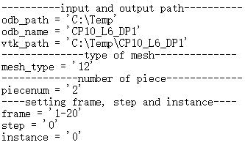

Fig. 2. The content of configuration file

Using this function, the script opens the configuration file and reads the information, then starts the conversion. This avoids the need to type complex parameters in command line, and is particularly convenient for users who are unfamiliar with Python.

Function2:

ConvertOdb2VtkP(Odbpath=' ', Odbname=' ', Vtkpath=' ', Meshtype=' ',

Piecenum=' ', Beginframe=' ', Endframe=' ', Step=' ', Instance=' ')

NOTE: “Odbpath=”,“Odbname=” …“Instance=” here are specifying the arguments, actually not necessary to type into the function, see below.



This function is an alternative. It needs all abovementioned parameters as input arguments.

# 4 Examples

Two example data are provided in the release package. One of them is:

* Name: CP10_L6_DP1
* Mesh type: hexahedron
* Instances: 1 instance
* Steps and Frames: 1 step with 20 frames
* Variables: displacement, velocity, acceleration, reaction force, stress and strain components

To convert all results in this ODB file to VTK format, a configuration file is organized as shown in Fig. 2. Then type ConvertOdb2Vtk(…)



The script prints information to illustrate the progress:

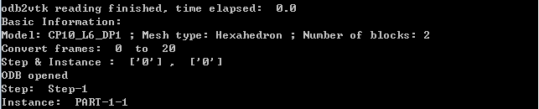

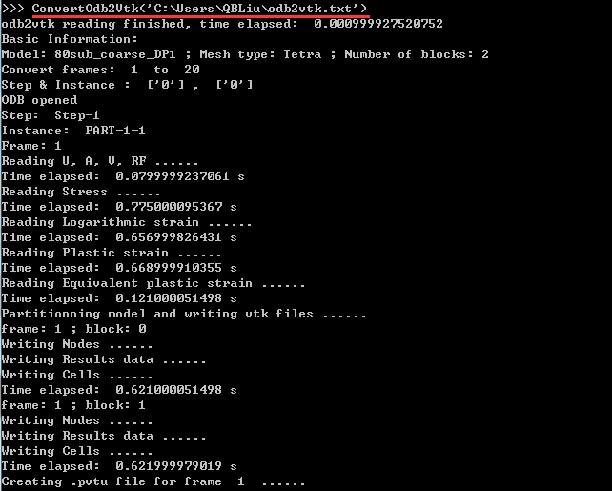

Comparison of visualization:

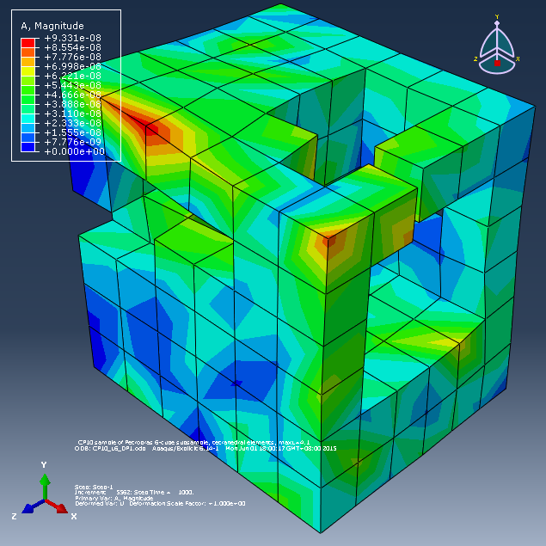a)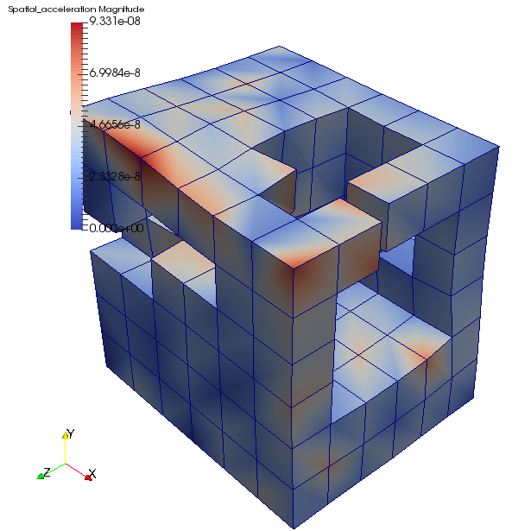b)

Fig. 3. a) Open the model using Abaqus; b) Open the model using ParaView

(Model: CP10_L6_DP1, Frame: 20, Variable: acceleration)

Another example (80sub_coarse_DP1) is with tetrahedron elements.